**Abstract:**

This project presents the design and development of a reliable gas leakage detection system focused on detecting a range of harmful gases including ammonia, benzene, smoke, and others. The device utilizes an MQ-135 gas sensor coupled with an Arduino Uno microcontroller for processing and decision-making. When potentially dangerous gas concentrations are detected, the system activates both a buzzer and an LED to alert the user.

**Introduction:**

Gas leaks can pose significant risks in various environments, from homes to industrial facilities. To ensure safety and prevent accidents, it’s crucial to detect gas leaks promptly. In this article, we will guide you through the process of building a gas leakage detector using an Arduino Nano, an MQ135 gas sensor, an I2C 20×4 LCD, red and green LEDs, and a SIM800 GSM module. This DIY project will help you create a reliable gas detection system with real-time alerts.

**Methodology:**

* **Components:**

1. **Arduino UNO**: A microcontroller board based on the ATmega328P. It has digital input/output pins, analog inputs, a USB connection for programming, and power management features.
2. **LCD I2C Display**: A liquid crystal display that uses the I2C communication protocol for displaying text and numbers.
3. **MQ 135 Sensor**: A gas sensor used for air quality monitoring, capable of detecting a wide range of gases including NH3, NOx, alcohol, benzene, smoke, and CO2.
4. **XL4015 5A DC Buck Step-down**: A DC-DC step-down (buck) converter module capable of handling up to 5A of current, used to reduce input voltage to a lower output voltage.
5. **LED: Two Pin (green)**: A green light-emitting diode used as an indicator light.
6. **LED: Two Pin (red)**: A red light-emitting diode used as an indicator light.
7. **Piezo Buzzer**: An electronic device that produces sound when an electrical signal is applied.
8. **SIM800L GSM Module**: A cellular communication module that allows the circuit to send SMS, make calls, or connect to the internet over a GSM network.

* 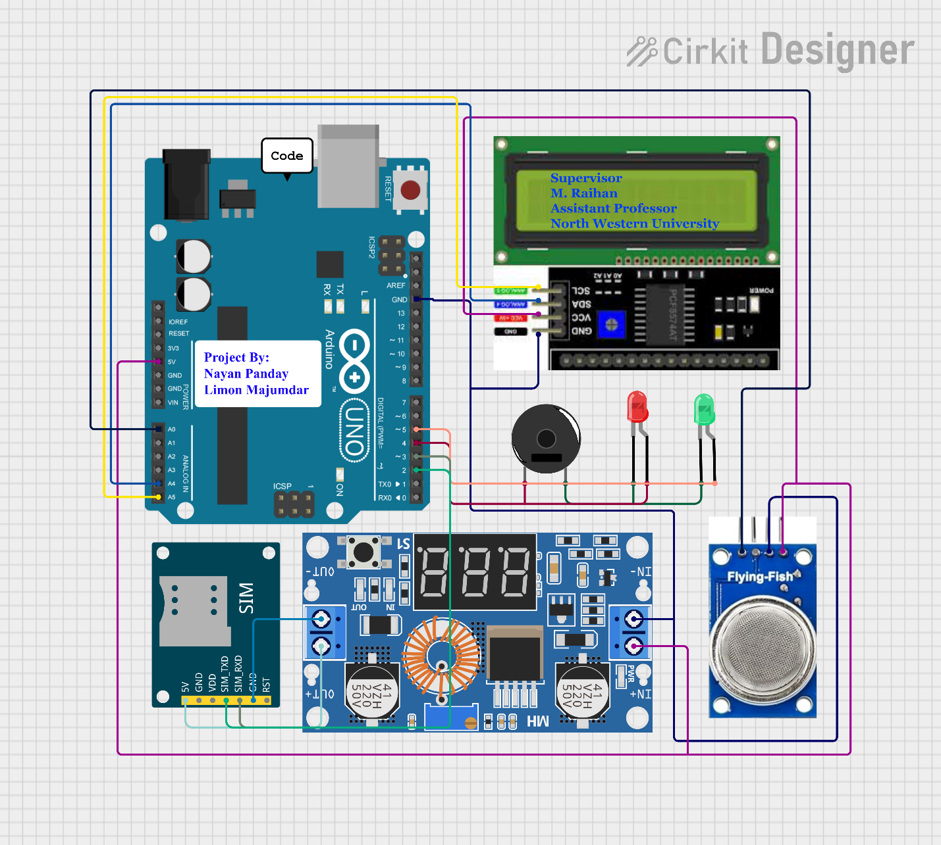**Circuit Design:**
* Connect the VCC pin of the MQ135 sensor to the 5V pin of the Arduino Uno.
* Connect the GND pin of the MQ135 sensor to the GND pin of the Arduino Uno.
* Connect the AOUT pin of the MQ135 sensor to the A0 analog input pin of the Arduino Uno.
* Connect the SDA pin of the LCD to the A4 pin (SDA) of the Arduino Uno.
* Connect the SCL pin of the LCD to the A5 pin (SCL) of the Arduino Uno.
* Connect the positive leg of the red LED to pin 4 of the Arduino Uno.
* Connect the positive leg of the green LED to pin 5 of the Arduino Uno.
* Connect the SIM800 GSM module Tx to 2 and RX to 3 Pin of the Arduino Uno.
* **AR Diagram:**

* **Programming:**
  + **Sensor Reading:** Continuous reading of the analog output from the MQ-135.
  + **Calibration:** Determine the sensor's baseline output in clean air and establish safe gas concentration thresholds through testing in controlled environments.
  + **Alarm Logic:** Implementation of conditional statements to activate the buzzer and LED when gas concentrations exceed the defined thresholds.
  + **Code:** Provide the well-commented Arduino code.

**Setup () Function**

* + The randomSeed() the function is used to initialize the random number generator with an analog input value.
  + Serial communication is initialized with a baud rate of 9600.
  + The LCD display is initialized and the backlight is turned on.
  + Pin modes for gasValue, Red, and Green are set to INPUT and OUTPUT, respectively.
  + The setup routine
* void setup() {
* pinMode(gasValue, INPUT);
* pinMode(redPin, OUTPUT);
* pinMode(greenPin, OUTPUT);
* lcd.print("     WELCOME TO ");
* lcd.setCursor(0, 1);
* lcd.print("   LIMON MAJUMDAR");
* lcd.setCursor(0, 2);
* lcd.print("    NAYAN PANDAY");
* lcd.setCursor(0, 3);
* lcd.print("      PROJECT");
* delay(4000);
* lcd.clear();
* lcd.print("Gas Leakage Detector");
* lcd.setCursor(0, 1);
* lcd.print("     Supervisor");
* lcd.setCursor(0, 2);
* lcd.print("     M. RAIHAN");
* lcd.setCursor(0, 3);
* lcd.print("NORTH WESTERN KHULNA");
* delay(6000);
* lcd.clear();

**Loop() Function**

* + Analog reading from the gas sensor is performed using, and the value is stored in the data variable.
  + Gas level information is printed to the Serial monitor and displayed on the LCD.
  + If the gas level exceeds a threshold value (80 in this case), the SendMessage() function is called to send an SMS alert.
  + The LCD display is updated accordingly and the red LED is turned on while the green LED is turned off.
  + If the gas level is below the threshold, the LCD display and LEDs are updated to indicate normal gas levels.
* void loop() {
* data = analogRead(gasValue);
* Serial.print("  Gas Level: ");
* Serial.println(data);
* lcd.clear();
* if (data > 400) {
* lcd.print("GAS LEAK DETECTED!");
* } else {
* lcd.print("  Gas Scan: Active   ");
* }
* delay(500);
* lcd.setCursor(0, 1);
* lcd.print("   Gas Level: ");
* lcd.print(data);
* delay(500);
* if (data > 400) {
* lcd.setCursor(0, 2);
* lcd.print("SMS Alert Sent      ");
* } else {
* lcd.setCursor(0, 2);
* lcd.print("                    ");
* }
* delay(500);
* lcd.setCursor(0, 3);
* if (data > 400) {
* lcd.print("LED: RED            ");
* } else {
* lcd.print("     LED: GREEN     ");
* }
* delay(500);
* if (data > 400) {
* SendMessage();
* analogWrite(redPin, 255);
* digitalWrite(greenPin, LOW);
* } else {
* analogWrite(greenPin, 255);
* digitalWrite(redPin, LOW);
* }
* delay(2000);

**SendMessage() Function**

* + This function is responsible for sending an SMS alert using the SIM800 GSM module.
  + AT commands are sent via the mySerial software serial connection to configure the GSM module and send the SMS.
  + The destination phone number, message content, and control characters are sent sequentially.
  + A delay is added to allow time for the SMS to be sent.
* void SendMessage() {
* Serial.println("I am in send");
* mySerial.println("AT+CMGF=1");
* delay(1000);
* mySerial.println("AT+CMGS=\"+8801987080310\"\r");
* mySerial.println("Gas Leakage Detected !!Open Windows And Check Your Gas Cylinder!!");
* delay(100);
* mySerial.println((char)26);
* delay(1000);
* }

**Results:**

* **When gas Levels are normal:**

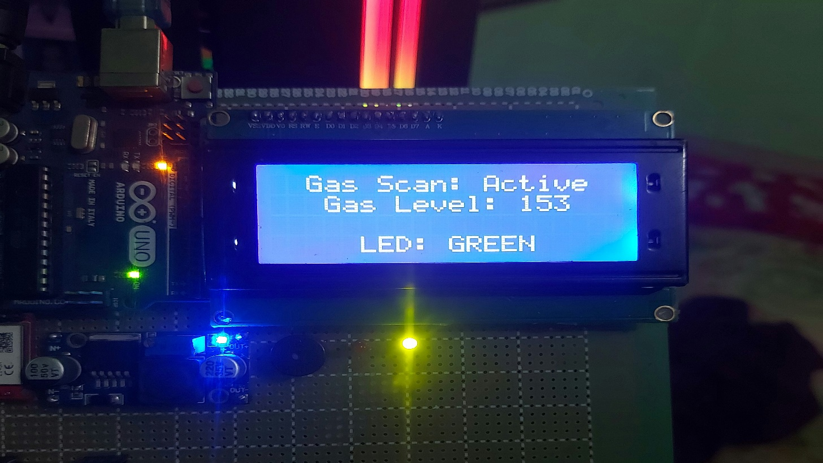

* **When gas Detected:**

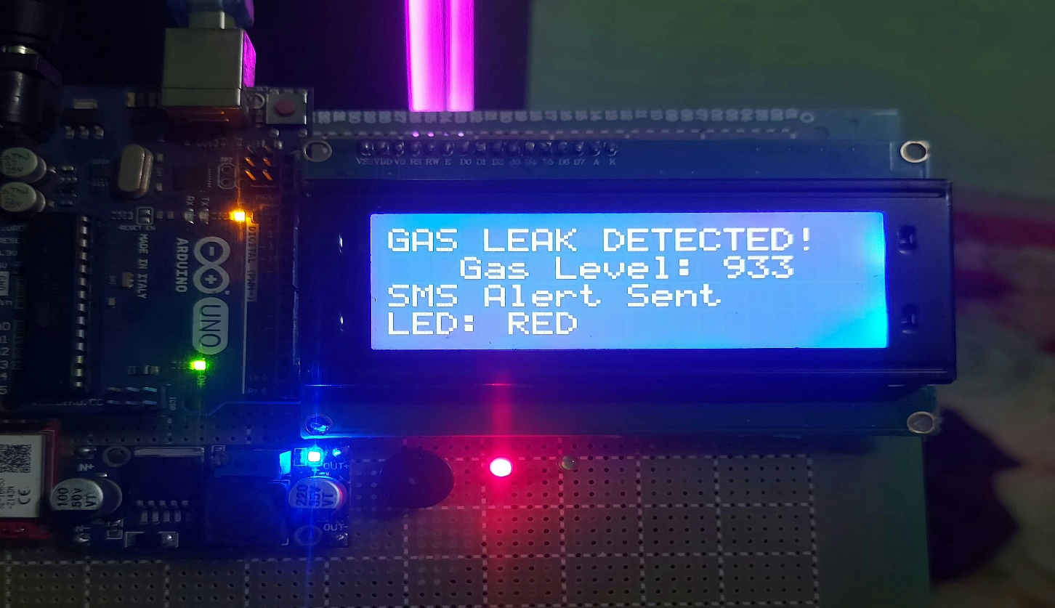

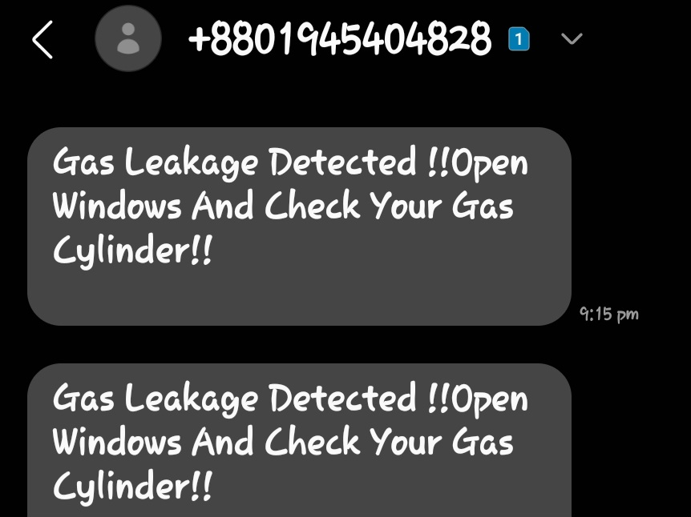

**Discussion:**

* The performance and effectiveness of the gas leakage detector.
* Limitations of the MQ-135 sensor (e.g., cross-sensitivity, influence of environmental factors).
* Potential Improvements:
  + GSM module integration for remote alerts.
  + Automatic gas shut-off valve mechanism.
  + LCD for displaying detailed gas readings.
  + Battery backup.
  + Alternative sensors for even higher specificity.

**Conclusion:**

This project successfully developed a gas leakage detection system. This system has the potential to improve safety in homes and industries by providing early warnings of dangerous gas leaks. The creation of a reliable and affordable gas leakage detector could significantly reduce the risk of fires, explosions, and health hazards. This project contributes to a safer environment for everyone. This project lays a foundation for advanced gas leakage detection and prevention. Further improvements could include IoT integration for real-time monitoring and the addition of automatic safety responses.

North Western University



LAB REPORT

Course Title: Advanced Programming Laboratory

Course Code: CSE-3200

Project Name: Gas Leakage Detector

**Submitted By**

**Name: Limon Majumdar**

**ID: 20212011010**

**Name: Nayan Panday**

**ID:20212012010**

**Department:** CSE 3.2 4Y

**North Western University**

**Submitted To**

**M. Raihan**

**Assistant Professor**

**Department of CSE**

**North Western University**

Date of Submission: 16-05-24